Figure : Number of publications investigating each type of intervention grouped and coloured by broad intervention category. Bubble size reflects the number of publications.

Figure : Number of publications within Amazon or not.

Figure : Number of publications within Amazon or not.

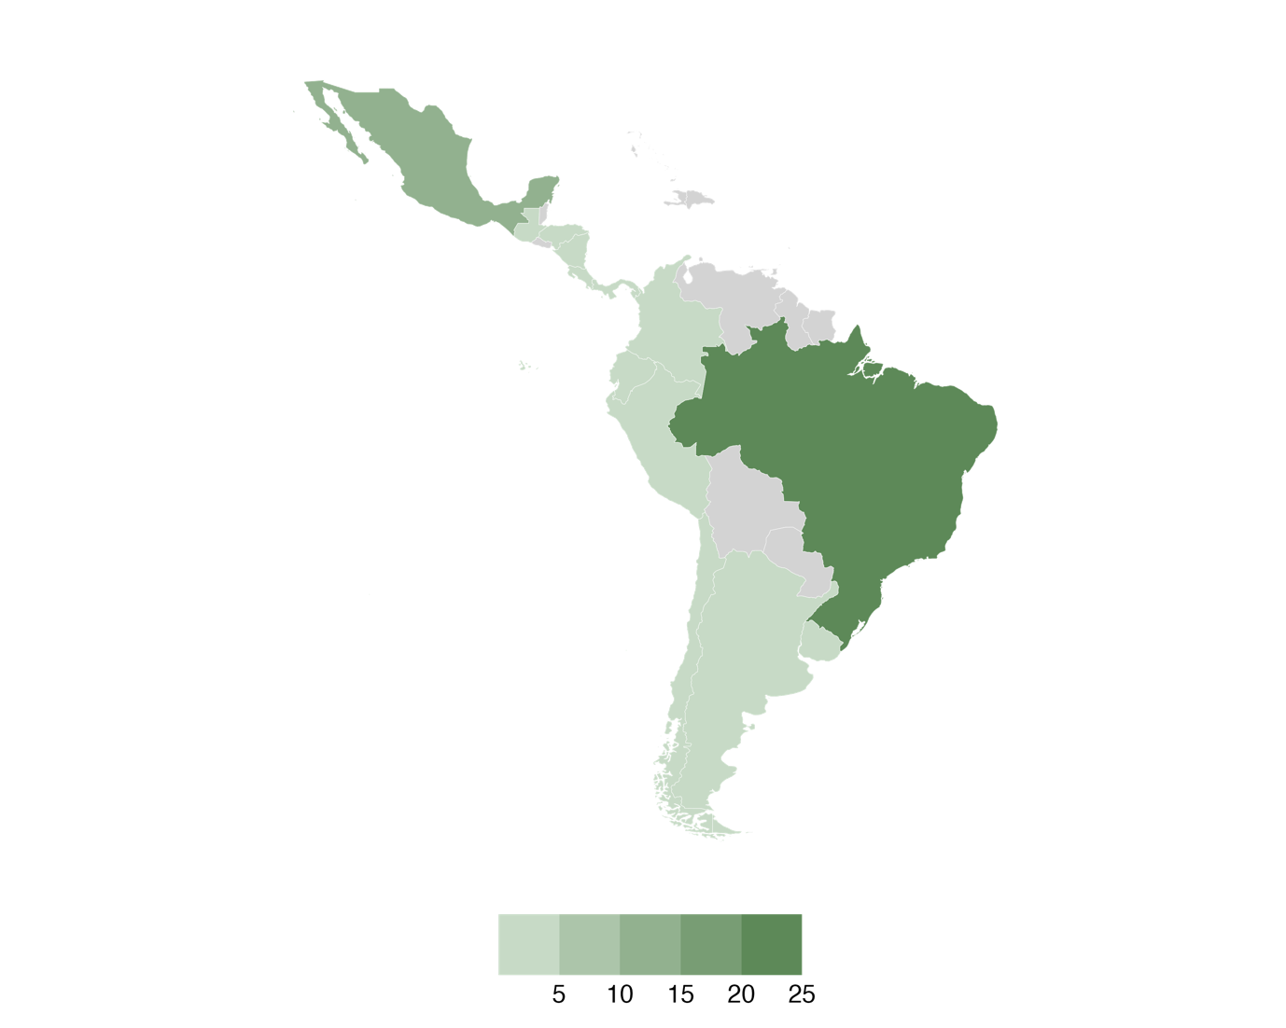

Figure : Number of publications within each region.

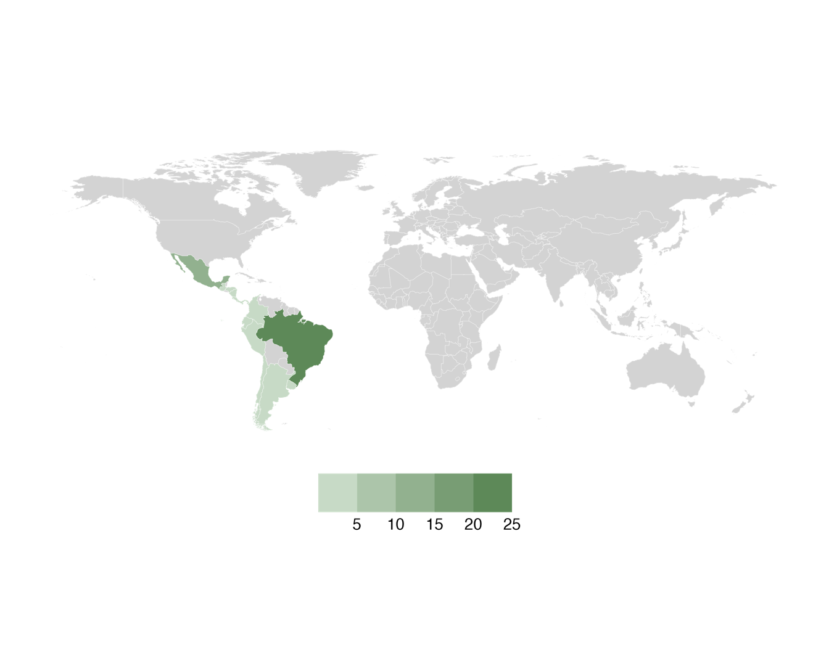

Figure : Number of publications within each region.

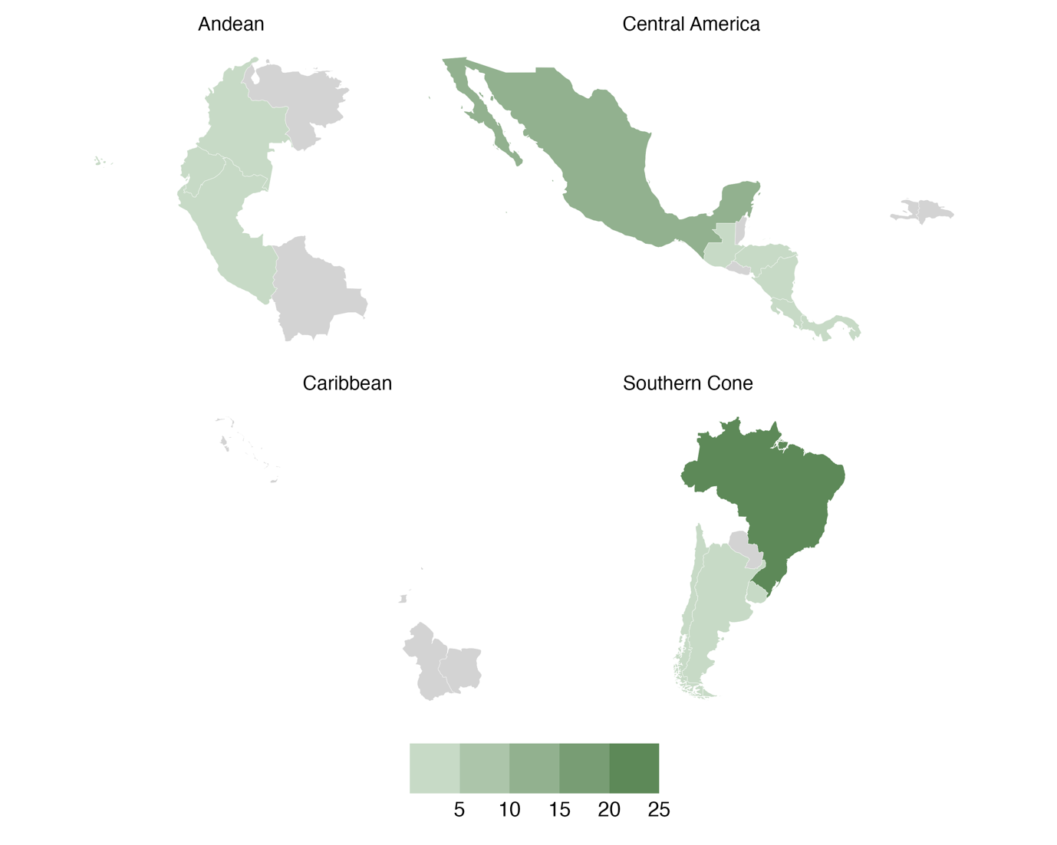

Figure : Number of publications within each IDB region.

Figure : Number of publications investigating each country and primary crop.

Figure : Number of publications investigating each agricultural subsector and broad intervention category.

Figure : Number of publications investigating each diverse population type and broad intervention category.

Figure : Number of publications investigating each climate perspective and broad intervention category.

Figure : Number of publications investigating each IDB region and broad intervention category.

Figure : Number of publications investigating each IDB region and primary livestock type.

Figure : Number of publications investigating each IDB region and livestock type.

Figure : Number of publications investigating each IDB region and primary crop.

Figure : Number of publications investigating each country and broad intervention category.

Figure : Number of publications investigating each country and primary livestock type.

Figure : Number of publications investigating each country and livestock type.